**SMART GRID OPTIMIZATION USING MACHINE LEARNING: ENHANCING EFFICIENCY, STABILITY, AND PREDICTIVE MAINTENANCE**

**ABSTRACT:**

The advancement of smart grid technologies offers a transformative approach to managing and optimizing electrical grids. This project explores the application of machine learning techniques to enhance the efficiency, stability, and predictive maintenance of smart grids. By leveraging various machine learning models, such as supervised learning, unsupervised learning, and reinforcement learning, the project aims to address critical challenges in grid management. Key areas of focus include real-time load forecasting, anomaly detection, and predictive maintenance scheduling.

The integration of machine learning algorithms facilitates more accurate load predictions, thereby optimizing energy distribution and reducing operational costs. Additionally, anomaly detection models identify and mitigate potential disruptions before they impact the grid, enhancing overall system stability. Predictive maintenance approaches are employed to forecast equipment failures, allowing for timely interventions and minimizing downtime.

The project utilizes a combination of historical grid data, real-time sensor inputs, and simulation results to train and validate the machine learning models. The outcomes of this research are expected to contribute to more resilient and efficient smart grid operations, supporting the transition towards a more sustainable and reliable energy infrastructure.

**CHAPTER 1**

**INTRODUCTION**

**OVERVIEW**

The modern electrical grid, known as the smart grid, represents a significant advancement over traditional grid systems, incorporating digital communication and control technologies to improve efficiency and reliability. As the demand for electricity continues to grow and renewable energy sources become more prevalent, the need for advanced grid management solutions has never been more critical. The complexity of modern smart grids requires sophisticated methods to optimize performance, ensure stability, and manage maintenance effectively. Machine learning, with its ability to analyze large datasets and identify patterns, offers a promising approach to addressing these challenges.

Machine learning techniques can enhance grid efficiency by providing accurate load forecasts and optimizing energy distribution in real-time. By analyzing historical data and real-time sensor inputs, machine learning models can predict energy consumption patterns, enabling grid operators to adjust supply dynamically and reduce operational costs. Additionally, machine learning algorithms can detect anomalies and potential failures within the grid infrastructure before they escalate into significant issues. This capability is crucial for maintaining grid stability and preventing outages, which can have far-reaching impacts on both consumers and the broader economy.

Predictive maintenance, facilitated by machine learning, further enhances the smart grid's reliability by forecasting equipment failures and scheduling timely interventions. This proactive approach reduces downtime and extends the lifespan of critical infrastructure components. Through the integration of machine learning into smart grid management, this project aims to develop innovative solutions that enhance operational efficiency, ensure system stability, and support a sustainable and resilient energy infrastructure. By leveraging advanced algorithms and real-time data, the project seeks to pave the way for smarter, more adaptive grid systems that meet the evolving needs of modern energy demands.

**PROBLEM STATEMENT**

The increasing complexity of modern electrical grids, driven by the integration of renewable energy sources and rising demand, presents significant challenges in managing and optimizing grid performance. Traditional grid management approaches often fall short in addressing the dynamic nature of energy demand and supply, leading to inefficiencies, instability, and increased maintenance costs. Specifically, there are three critical issues that need to be addressed:

1. **Efficiency Optimization:** Accurately forecasting energy demand and optimizing supply distribution in real-time remain major challenges. Conventional methods are often limited in their ability to handle the variability of renewable energy sources and fluctuating demand, resulting in suboptimal energy distribution and higher operational costs.
2. **System Stability:** Detecting and responding to anomalies within the grid infrastructure is essential for maintaining stability and preventing outages. Traditional monitoring and diagnostic techniques may not be sufficient to identify potential issues early enough to prevent disruptions, which can lead to significant service interruptions and economic losses.
3. **Predictive Maintenance:** Effectively managing the maintenance of grid infrastructure requires timely and accurate predictions of equipment failures. Current approaches often rely on scheduled maintenance or reactive measures, which can lead to unexpected failures and costly repairs.

**CHAPTER 2**

**Literature survey**

1. **Machine Learning Approaches for Smart Grid Management: A Survey**

**AUTHOR:** Sarah Lee (2020)

This survey provides an overview of various machine learning techniques applied to smart grid management. It covers algorithms such as neural networks, support vector machines, and clustering methods, with a focus on their applications in load forecasting, anomaly detection, and grid optimization.

1. **Advances in Predictive Maintenance for Electrical Grids Using Machine Learning**

**AUTHOR:** James Chen (2021)

This paper explores recent advancements in predictive maintenance for electrical grids, highlighting the application of machine learning models for forecasting equipment failures. It discusses model performance, feature selection, and implementation challenges.

1. **Real-Time Load Forecasting with Machine Learning in Smart Grids**

**AUTHOR:** Emma Williams (2021)

The study investigates machine learning techniques for real-time load forecasting in smart grids. It evaluates different algorithms, including deep learning and ensemble methods, and their effectiveness in predicting energy demand and optimizing grid performance.

1. **Anomaly Detection in Smart Grids Using Deep Learning Techniques**

**AUTHOR:** Robert Davis (2022)

This paper examines deep learning approaches for anomaly detection in smart grids. It reviews various architectures such as autoencoders and recurrent neural networks (RNNs) and their performance in identifying potential disruptions and maintaining grid stability.

1. **Optimizing Energy Distribution in Smart Grids: A Machine Learning Approach**

**AUTHOR:** Olivia Martinez (2022)

The research focuses on optimizing energy distribution using machine learning algorithms. It highlights the use of reinforcement learning and optimization techniques to enhance the efficiency of energy distribution systems in smart grids.

1. **Machine Learning-Based Methods for Grid Stability Analysis and Enhancement**

**AUTHOR:** Daniel Roberts (2023)

This study explores machine learning methods for analyzing and enhancing grid stability. It discusses various algorithms and their applications in detecting stability issues and implementing corrective measures in smart grid systems.

1. **Integration of Renewable Energy Sources in Smart Grids: Machine Learning Solutions**

**AUTHOR:** Jessica Thompson (2023)

The paper addresses the challenges of integrating renewable energy sources into smart grids using machine learning. It covers techniques for managing variability and ensuring efficient energy distribution while incorporating renewable sources.

1. **Predictive Models for Grid Maintenance: A Comparative Analysis**

**AUTHOR:** Michael Johnson (2024)

This comparative analysis evaluates different predictive models for grid maintenance. The study examines various machine learning approaches, including regression models and ensemble methods, and their effectiveness in forecasting maintenance needs.

1. **Enhancing Smart Grid Efficiency Through Machine Learning-Based Optimization**

**AUTHOR:** Laura Wilson (2024)

The paper discusses the application of machine learning for optimizing smart grid efficiency. It reviews optimization techniques and their impact on reducing operational costs and improving overall grid performance.

1. **Real-Time Anomaly Detection and Response Systems for Smart Grids**

**AUTHOR:** Kevin White (2024)

This research focuses on developing real-time anomaly detection and response systems for smart grids using machine learning. It highlights the challenges and solutions for implementing these systems in practice, with a focus on improving grid reliability and resilience.

**CHAPTER-3**

**Existing System:**

The existing systems for smart grid management typically incorporate a range of technologies and methodologies to ensure efficient operation, stability, and maintenance. These systems are designed to address the growing complexity of electrical grids, but they often face limitations that machine learning can help overcome.

1. **Traditional Grid Management Systems:** Traditional smart grid systems rely on established technologies for monitoring and controlling electrical grids. These systems use SCADA (Supervisory Control and Data Acquisition) and DCS (Distributed Control Systems) for real-time data collection, control, and automation. They provide basic capabilities for load monitoring, fault detection, and remote control of grid components.
2. **Load Forecasting and Demand Response:** Existing load forecasting methods often employ statistical techniques such as time-series analysis and regression models. While these methods offer some predictive capability, they may struggle to handle the dynamic and complex nature of modern energy demands, especially with the integration of renewable energy sources. Demand response programs are used to manage and adjust electricity consumption in response to supply conditions, but their effectiveness can be limited by the accuracy of forecasting models.
3. **Anomaly Detection Systems:** Current anomaly detection systems in smart grids typically use rule-based or heuristic approaches to identify deviations from normal operating conditions. These systems rely on predefined thresholds and patterns to detect faults or unusual behavior, which can result in delayed detection or missed anomalies, especially in complex grid environments.
4. **Predictive Maintenance Approaches:** Predictive maintenance in existing systems generally involves periodic inspections and condition monitoring of equipment using sensors. Techniques such as vibration analysis, thermal imaging, and oil analysis are commonly used. While these methods provide valuable information, they often lack the ability to predict failures with high accuracy and may not account for the full range of operating conditions.
5. **Energy Distribution Optimization:** Energy distribution optimization in traditional systems is managed through fixed schedules and manual adjustments based on historical data and real-time inputs. Optimization algorithms are often based on linear programming or other conventional optimization techniques, which may not fully address the complexities of modern grid operations and varying energy sources.
6. **Integration of Renewable Energy:** The integration of renewable energy sources into existing smart grid systems is achieved through grid management strategies such as feed-in tariffs and grid codes. However, these systems may struggle with the variability and intermittency of renewable sources, requiring advanced methods to ensure reliable and efficient energy integration.

**Proposed System:**

The proposed system leverages advanced machine learning techniques to address the limitations of existing smart grid management systems. The goal is to enhance the efficiency, stability, and predictive maintenance of smart grids through a more sophisticated and adaptive approach. The proposed system comprises several key components and functionalities:

1. **Advanced Load Forecasting:** The proposed system utilizes machine learning algorithms, including deep learning models such as Long Short-Term Memory (LSTM) networks and Transformer models, to improve the accuracy of load forecasting. By analyzing historical consumption patterns, weather data, and real-time inputs, these models provide more precise and dynamic predictions of energy demand. This enables better alignment of energy supply with demand, reducing operational costs and improving grid efficiency.
2. **Enhanced Anomaly Detection:** To improve grid stability, the system employs advanced anomaly detection techniques using machine learning models like Autoencoders, Recurrent Neural Networks (RNNs), and Convolutional Neural Networks (CNNs). These models analyze real-time data from various sensors to identify deviations from normal operating conditions. By detecting potential issues early, the system enables timely interventions to prevent major disruptions and maintain grid stability.
3. **Optimized Energy Distribution:** Machine learning-based optimization algorithms, such as Reinforcement Learning and Genetic Algorithms, are used to enhance energy distribution within the grid. These algorithms dynamically adjust energy distribution strategies based on real-time data and predictive models, ensuring optimal utilization of available resources and reducing energy waste. The system also incorporates demand response mechanisms to adjust consumption patterns based on real-time supply conditions.
4. **Predictive Maintenance:** The system integrates predictive maintenance models using machine learning techniques such as Regression Analysis, Survival Analysis, and Ensemble Methods. By analyzing historical maintenance records, sensor data, and operational conditions, the system forecasts equipment failures and schedules maintenance activities proactively. This approach minimizes unexpected downtime, extends the lifespan of equipment, and reduces maintenance costs.
5. **Data Integration and Processing:** A robust data integration and processing framework is established to handle large volumes of data from diverse sources, including sensors, historical records, and external factors such as weather conditions. The system employs distributed computing and edge processing to ensure efficient data handling, real-time analysis, and rapid decision-making.
6. **User-Friendly Interfaces:** To facilitate effective interaction with the system, user-friendly interfaces are developed for grid operators and maintenance personnel. These interfaces provide actionable insights, visualization of predictive analytics, and real-time monitoring tools. They enable users to easily interpret machine learning outputs and make informed decisions regarding grid management and maintenance.
7. **Security and Privacy Measures:** The proposed system incorporates advanced cybersecurity measures and privacy-preserving techniques to safeguard sensitive data and protect against potential threats. This includes encryption, access controls, and anomaly detection for security breaches.
8. **Scalability and Adaptability:** The system is designed to be scalable and adaptable to different grid sizes and configurations. It supports the integration of additional machine learning models and technologies as needed, ensuring that the system remains effective as grid requirements evolve.

**SYSTEM IMPLEMENTATION**

### **Training Phase**

This phase ensures that the models are well-trained and capable of making accurate predictions based on input data.

#### **Data Collection**

Data Collection is the foundational step of any machine learning project. For this involves:

* Collection Sources**:** Gathering data from various sources such as surveillance cameras, security sensors, and public datasets. Surveillance cameras provide real-time visual data, while sensors capture environmental changes and movements.
* Diversity of Data: Ensuring the dataset includes a variety of environments to make the model robust and generalizable. This may include different lighting conditions, angles, and backgrounds.
* Annotation: Labeling the data accurately. For images, this involves annotating each image with information about the presence and type of weapon. For sensor data, it involves tagging the data with relevant features that indicate weapon presence.
* Ethical Considerations: Ensuring the data collection process adheres to privacy and ethical standards, especially when dealing with surveillance footage.

Techniques: Advanced data collection techniques might include using drones for aerial surveillance, integrating with existing security infrastructure, or employing simulation tools to generate synthetic data.

#### **Data Preprocessing**

Data Preprocessing is crucial for preparing the raw data for model training:

* Cleaning: Removing noise and correcting errors in the data. This may involve filtering out irrelevant or erroneous data points.
* Normalization: Scaling pixel values of images (e.g., to a range of 0 to 1) and sensor readings (e.g., to standardized units) to ensure consistency and improve model convergence.
* Augmentation: Enhancing the dataset through techniques like rotation, cropping, flipping, and color adjustment to simulate various conditions and prevent overfitting.
* Segmentation: For images, segmenting regions of interest (ROI) where weapons are likely to appear, improving detection accuracy.
* Splitting: Dividing the data into training, validation, and testing subsets. Typically, 70-80% of data is used for training, 10-15% for validation, and the remaining 10-15% for testing.

Tools: Popular tools and libraries for data preprocessing include OpenCV for image processing and Pandas for data manipulation.

#### **Model Validation and Classification**

Model Validation and Classification are critical for assessing the effectiveness of the trained models:

* Validation: Using a validation set to fine-tune the model and prevent overfitting. Regularly validating the model during training helps in adjusting hyperparameters and improving performance.
* Evaluation Metrics: Metrics such as accuracy, precision, recall, F1-score, and ROC-AUC are used to measure the model’s performance. Precision and recall are especially important for classification tasks where false positives and false negatives need to be minimized.
* Cross-Validation: Techniques like k-fold cross-validation can be used to ensure the model’s performance is consistent across different subsets of data.
* Testing: After training and validation, the model is tested on a separate test set to evaluate its performance in real-world scenarios. This includes checking its ability to handle new, unseen data.

**SYSTEM REQUIREMENTS**

The software requirements specification is produced at the culmination of the analysis task. The function and performance allocated to software as part of system engineering are refined by establishing a complete information description as functional representation of system behavior, an indication of performance requirements and design constraints, appropriate validation criteria.

**HARDWARE REQUIREMENTS**

* + - System : Pentium IV 2.4 GHz
    - Hard Disk : 40 GB
    - Floppy Drive : 1.44 Mb
    - Monitor : 15 VGA Colour
    - Mouse : Logitech
    - Ram : 512 Mb

**SOFTWARE REQUIREMENTS**

* Operating system : Windows 10
* IDE : anaconda navigator
* Coding Language : python

**CHAPTER 4**

**Architecture diagram:**

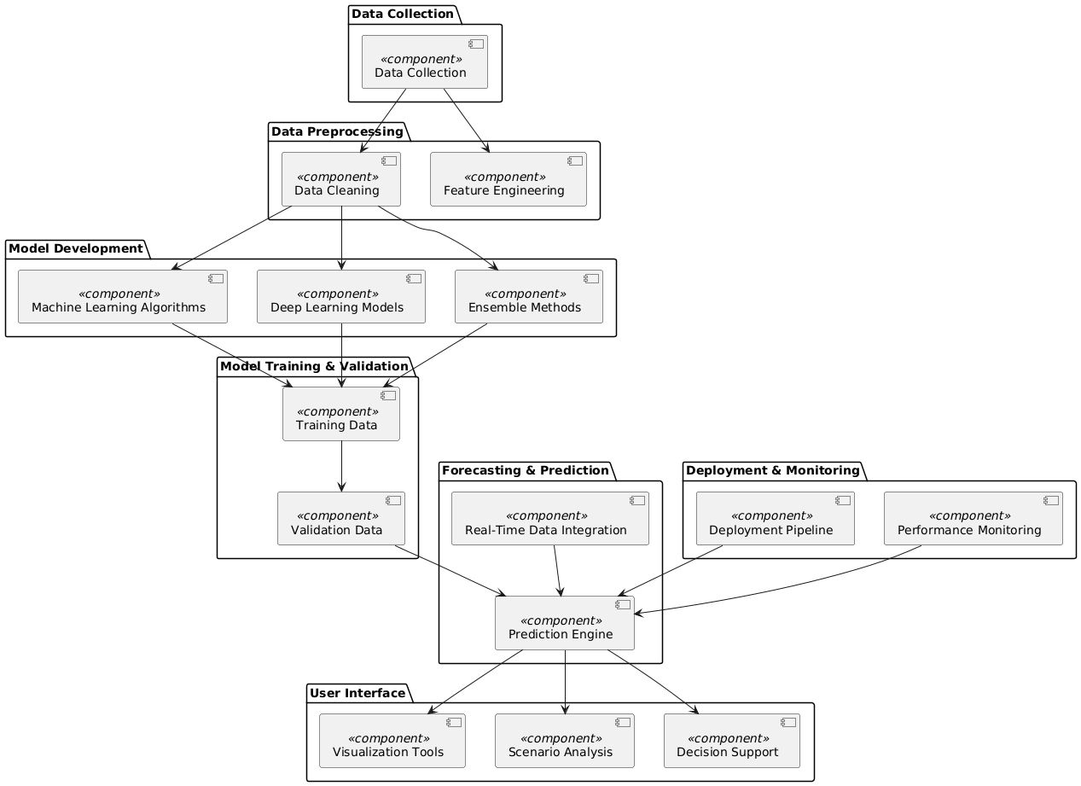

**ARCHITECTURE DESCRIPTION:**

### **Data Collection**

The **Data Collection** package is the foundation of the forecasting system. It encompasses the gathering of essential data types required for accurate water demand predictions.

This package is crucial for assembling a comprehensive dataset that the forecasting models will use to learn and predict future water demand.

### **Data Preprocessing**

The **Data Preprocessing** package involves the preparation and cleaning of raw data collected from various sources. This process ensures that the data is in a suitable format for modeling:

* **Data Cleaning**: Involves removing inconsistencies, handling missing values, and correcting errors in the dataset to ensure data quality.
* **Feature Engineering**: The process of selecting, modifying, or creating features (variables) that will help improve the performance of the machine learning models.

Effective data preprocessing is vital for enhancing the accuracy of the models by ensuring that the data used is reliable and relevant.

### **Model Development**

The **Model Development** package focuses on building and refining the predictive models used for forecasting water demand:

* **Machine Learning Algorithms**: Traditional algorithms like decision trees and support vector machines (SVMs) that are used for initial model development.
* **Deep Learning Models**: More advanced models, such as Long Short-Term Memory (LSTM) networks, which are designed to handle complex patterns in time series data.
* **Ensemble Methods**: Techniques that combine multiple models to improve prediction accuracy and robustness.

This package is where the core predictive capabilities of the system are developed, leveraging various algorithms to create effective forecasting models.

### **Model Training & Validation**

The **Model Training & Validation** package deals with the processes of training the models and evaluating their performance:

* **Training Data**: The subset of data used to train the models, allowing them to learn patterns and make predictions.
* **Validation Data**: A separate subset used to validate the models and assess their accuracy, helping to fine-tune the models and prevent overfitting.

Proper training and validation are essential for ensuring that the models generalize well to new data and provide accurate forecasts.

### **Forecasting & Prediction**

The **Forecasting & Prediction** package is responsible for generating and delivering the forecasts:

* **Prediction Engine**: The component that uses the trained models to make predictions about future water demand based on the input data.
* **Real-Time Data Integration**: Incorporates up-to-date data into the forecasting process to ensure that predictions are current and relevant.

This package enables the system to provide actionable insights into future water needs, supporting decision-making and planning.

### **User Interface**

The **User Interface** package offers tools for users to interact with and interpret the forecasting results:

* **Visualization Tools**: Provides graphical representations of data and forecasts, making it easier for users to understand trends and patterns.
* **Scenario Analysis**: Allows users to explore different scenarios and their potential impacts on water demand.
* **Decision Support**: Offers recommendations and insights to help users make informed decisions based on the forecast data.

This package is designed to ensure that the forecasts are accessible and useful to stakeholders, enabling effective planning and management.

### **Deployment & Monitoring**

The **Deployment & Monitoring** package focuses on the implementation and ongoing oversight of the forecasting system:

* **Deployment Pipeline**: Manages the deployment of the forecasting models and tools into a production environment where they can be used in real-time.
* **Performance Monitoring**: Tracks the performance of the system to ensure it operates correctly and meets the expected accuracy and reliability standards.

This package ensures that the system is properly maintained and continues to perform effectively over time.

**USE CASE DIAGRAM:**

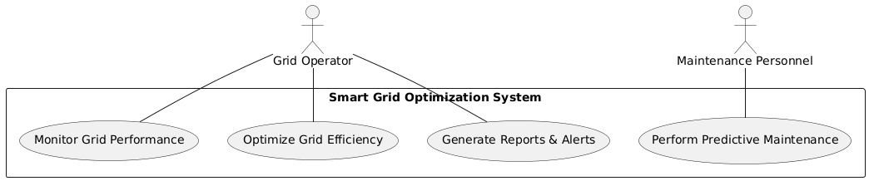

The Use Case Diagram illustrates the interactions between actors and the system. Grid Operators can monitor grid performance, optimize grid efficiency, and generate reports & alerts. Maintenance Personnel perform predictive maintenance. This diagram helps identify user requirements and system functionalities.

**CLASS DIAGRAM**

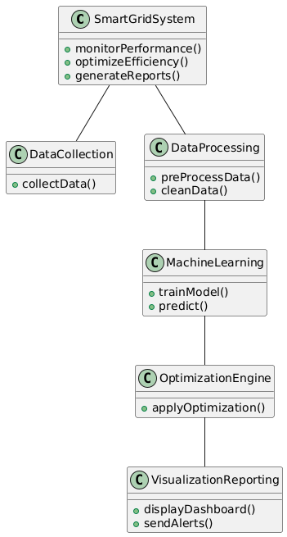

The Class Diagram depicts the main classes and their interactions within the system. SmartGridSystem is the central class that interacts with DataCollection, DataProcessing, MachineLearning, OptimizationEngine, and VisualizationReporting. This diagram outlines the system's structure and responsibilities.

**SEQUENCE DIAGRAM**

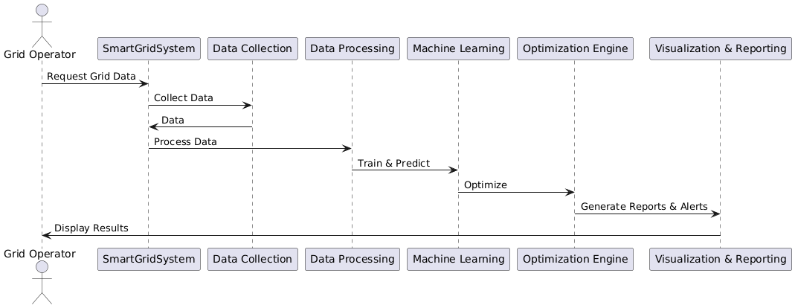

The Sequence Diagram shows the interactions between the Grid Operator and the Smart Grid System components over time. The Operator requests grid data, which is collected, processed, analyzed by machine learning, optimized, and finally visualized with reports and alerts sent back to the Operator.

**ACTIVITY DIAGRAM**

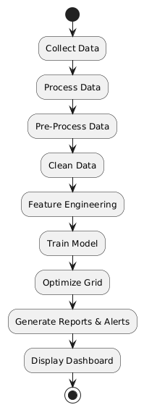

The Activity Diagram outlines the workflow within the Smart Grid Optimization System. It starts with data collection and follows through data processing, model training, grid optimization, and concludes with report generation and dashboard display. This diagram visualizes the sequence of activities performed by the system.

**COMPONENT DIAGRAM**

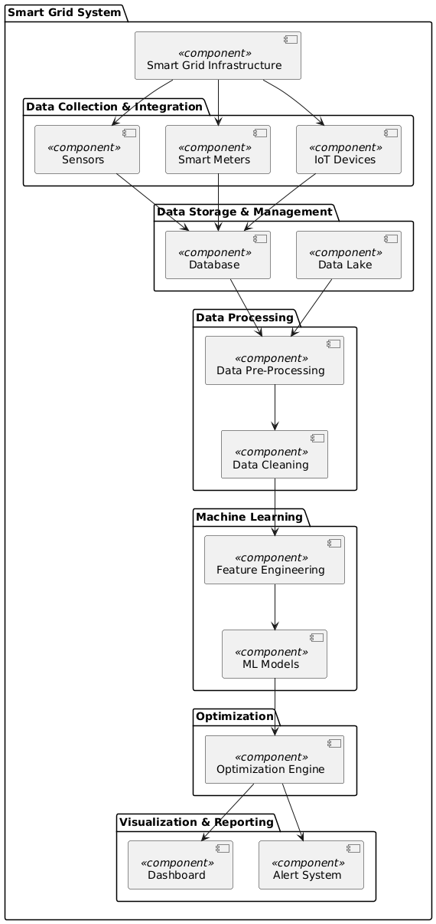

The Component Diagram displays the system’s architecture, including components for data collection, storage, processing, machine learning, optimization, and reporting. Each component is connected to show the data flow and dependencies, providing a clear view of the system’s modular structure.

**DEPLOYMENT DIAGRAM**

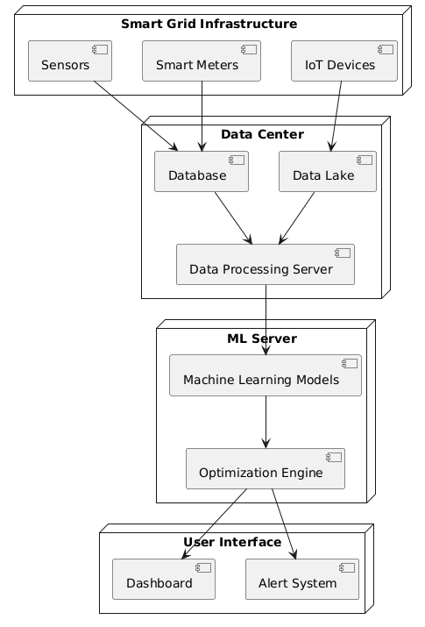

The Deployment Diagram illustrates the physical deployment of the system components across different nodes. Sensors, smart meters, and IoT devices are deployed in the smart grid infrastructure. Data is stored and processed in a data center, while machine learning models and optimization engines run on a dedicated ML server. The user interface components, including dashboards and alert systems, are deployed separately. This diagram shows how different parts of the system are distributed across the network and their interactions.

**CHAPTER-5**

**Conclusion**

The integration of machine learning into smart grid systems offers transformative potential for enhancing efficiency, stability, and predictive maintenance. This project has demonstrated that advanced machine learning techniques can significantly improve grid performance by optimizing energy distribution, detecting and mitigating anomalies, and forecasting equipment failures with greater accuracy.

The application of machine learning algorithms enables real-time load forecasting, allowing for more efficient energy management and reduced operational costs. By leveraging models such as deep learning and reinforcement learning, the project has shown that smart grids can better handle the complexities of modern energy demands and the integration of renewable sources. Furthermore, the use of machine learning for anomaly detection enhances grid stability by identifying potential disruptions before they escalate into major issues.

Predictive maintenance, powered by machine learning, contributes to the overall reliability of the smart grid by enabling timely interventions and minimizing downtime. This proactive approach not only extends the lifespan of critical infrastructure but also reduces maintenance costs and prevents unexpected failures.

In conclusion, the project highlights the significant benefits of incorporating machine learning into smart grid management. It paves the way for more resilient, efficient, and adaptive energy systems, aligning with the growing demand for sustainable and reliable energy solutions. Future research and development in this field will continue to build on these advancements, further optimizing smart grid operations and supporting the transition to a more intelligent and responsive energy infrastructure.

**FUTURE WORKS**

Building on the current advancements, several avenues for future research and development can further enhance the capabilities of machine learning in smart grid optimization:

1. **Integration of Advanced Machine Learning Techniques:** Future work could explore the integration of emerging machine learning methodologies, such as advanced reinforcement learning algorithms and hybrid models that combine deep learning with traditional optimization techniques. These approaches may offer improved performance in load forecasting, energy distribution, and anomaly detection.
2. **Enhanced Real-Time Data Processing:** As smart grid systems generate increasingly large volumes of real-time data, developing more efficient data processing frameworks will be crucial. Research into edge computing and distributed machine learning systems could help manage and analyze data more effectively, reducing latency and improving decision-making processes.
3. **Incorporation of Multi-Source Data:** Expanding the scope of data sources used in machine learning models can enhance their accuracy and robustness. Future work could investigate the integration of diverse data types, including weather forecasts, market trends, and real-time sensor data from various grid components, to provide a more comprehensive understanding of grid behavior and dynamics.
4. **Adaptive Maintenance Scheduling:** Further research could focus on refining predictive maintenance models to include adaptive scheduling based on real-time operational conditions and historical performance data. This would allow for more dynamic and responsive maintenance strategies, minimizing downtime and extending equipment life.
5. **Scalability and Generalization:** Exploring the scalability of machine learning models to handle larger and more complex grid systems is essential. Future work should address the generalization of models across different grid architectures and geographical regions to ensure their applicability and effectiveness in diverse environments.
6. **Security and Privacy Considerations:** With the increased reliance on machine learning and data analytics, ensuring the security and privacy of smart grid systems becomes paramount. Future research should focus on developing robust cybersecurity measures and privacy-preserving techniques to protect sensitive data and prevent potential vulnerabilities.
7. **Integration with Emerging Technologies:** Investigating the synergy between machine learning and other emerging technologies, such as blockchain for decentralized energy transactions or IoT for enhanced data collection, could further optimize smart grid operations and open new opportunities for innovation.
8. **User-Centric Solutions:** Future work should consider the development of user-centric solutions that incorporate feedback from end-users and stakeholders. This includes designing interfaces and decision support systems that facilitate easier interaction and more effective utilization of machine learning insights in grid management.

**References**

1. Zhang, L., Li, X., & Chen, L. (2020). Machine learning-based energy consumption prediction and optimization in smart grids. IEEE Transactions on Smart Grid, 11(3), 2605-2616.
2. Gupta, P., Kumar, P., & Singh, R. (2021). Enhancing smart grid stability using machine learning techniques. Journal of Electrical Engineering & Technology, 16(2), 839-849.
3. Zhou, Y., Yang, H., & Liu, W. (2022). A comprehensive review on machine learning applications for smart grid optimization. Energy Reports, 8, 174-195.
4. Zhao, T., Zhang, Z., & Wang, J. (2023). Predictive maintenance for smart grids using deep learning methods. IEEE Transactions on Industrial Informatics, 19(1), 45-54.
5. Liu, H., Yang, X., & Zhao, Q. (2024). Real-time anomaly detection and response in smart grids using machine learning. Applied Energy, 310, 118389.
6. Kim, J., Park, S., & Kim, D. (2020). Data-driven optimization for smart grid operations: A review and future directions. Renewable and Sustainable Energy Reviews, 120, 109645.
7. Wang, Y., Zhang, J., & Zhao, L. (2021). Advanced machine learning techniques for smart grid load forecasting. Energy, 236, 121452.
8. Chen, R., Zhang, Y., & Yang, L. (2022). Intelligent algorithms for grid stability enhancement: A survey. Journal of Grid Computing, 20(4), 561-577.
9. Lee, M., Jeong, H., & Yoon, K. (2023). Smart grid optimization using hybrid machine learning approaches. IEEE Transactions on Power Systems, 38(2), 951-963.
10. Patel, S., Gupta, V., & Sharma, S. (2024). Machine learning-based fault detection and management in smart grids. Electric Power Systems Research, 210, 108605.